SoilPak 250 – Enzyme System

- Clay based soils PI>8
- Improves compressive strength
- Reduces soil permeability
- Reduces soil plasticity
- Improves ability to compact soil to 100-105%
- Reduce free water associated with clays
- Reduces construction time
- Improves cycle time between repairs and rework

Polymer-CCDS-900

- Sand based soil PI < 8
- Chemically binds soil particles produces water resistant hardened base
- Reduces dust release and erosion
- Non-chloride solution
Uses standard construction equipment.
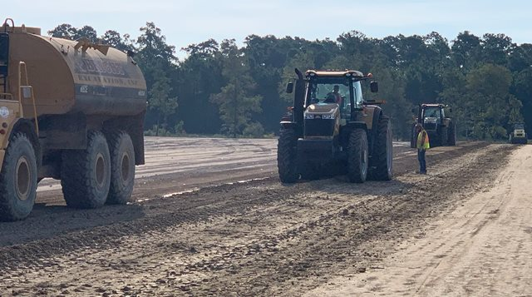
Contact us at: 405-392-3888

Environmentally Friendly Solutions
SoilChem, LLC Systems
- Biodegradable
- Spill clean-up with water
- Will NOT harm plants and animals
- Reduces air-borne dust and pollutants
- Utilizes Standard Construction Equipment and Processes
- Utilizes soils in place reducing material and transportation costs
- Improves durability of treated areas
- Concentrated solution provides ease in handling; Available in 5 gallon pails, 275 gallon IBC Totes, and Bulk Storage Containers with no special handling requirements.
- Cost effective
- Environmentally friendly soil solutions
- Non-corrosive to equipment

117 Snow Drive
Newcastle, OK USA 73065
Phone: 405-392-3888
Fax: 405-392-5656
www.soilchemllc.com
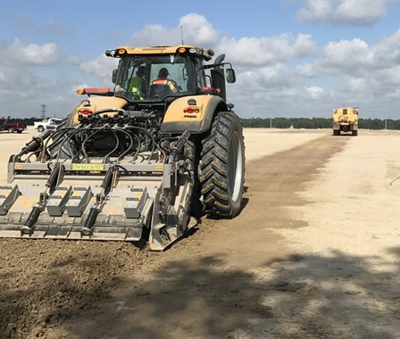
  - Soil Stabilization Products
- SoilPak -250
- Polymer-CCDS-900 Dust Control

Biodegradable ~ Long Lasting ~ Rock Hard

- Cost Effective
- Environmentally friendly soil solutions
For Product/Service Information
405-392-3888
Leading the way to a greener Earth.
Member ACCO OK

Economical and Environmentally Friendly Soil Stabilization Solutions
SoilChem, LLC provides environmentally friendly and cost effective products for soil stabilization yielding a durable and long lasting road bed capable of carrying heavy loads. Applications include Municipal Roads, Logging Roads, Parking Lots, Drill Site Pads and Access Roads, Air Strips, Mining Roads, Pipe Yards and Service Yards. The cost saving processes employs standard construction equipment and practices utilizing materials in place, saving material costs and hauling expenses.
The enzyme process in clay bearing soils, through chemical and ionic bonding processes, which breaks down the clays, reducing the soil plasticity, reduces free water associated with the clay particles, and reduces the soil permeability; rendering the treated area hydrophobic (water resistant). The processes results in improved workability. Full compaction to refusal can then be achieved with less mechanical effort yielding a rock hard base that light traffic can access 4 hours post application. Top coats can be applied 48 hours after initial application.
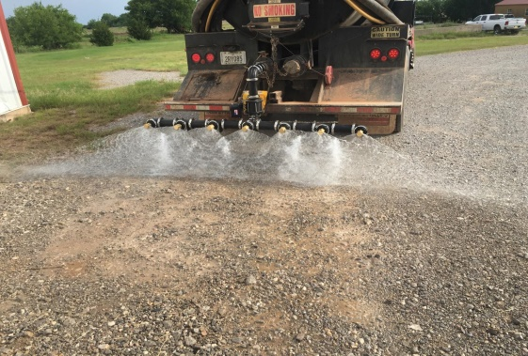
©SoilChem, LLC, 08012019

SoilPack-250-Enzyme

Path to success

- Take soil sample and survey area to be stabilized to determine plasticity (Atterberg Limits) and optimum water content (Proctor test).
- Rip road to optimum depth based on traffic loading. Apply enzyme solution through reclaimer, or post multiple pass construction disc with a water truck. Treated soil is checked for optimum water content.
- Sheepsfoot packer is next used to knead and compact the soil to refusal. A motor grader then crowns and grades the road followed by smooth drum packer, then smooth tire pneumatic roller and for a smooth ride. All steps must be completed within a 4 hour work window.
- A top coat of light gravel is recommended. Asphalt or chip and seal process can follow 48 hours post application. The area can be opened to light traffic
Results: Cost savings, long lasting durable road system that reduces rutting and sub-base premature failures caused by water intrusion and hydraulic micro fractures. Optimum compaction can be obtained during the construction process – the key to long lasting smooth road systems and pads.

Polymer Systems
SoilChem, LLC provides innovative, environmentally friendly, and cost effective soil stabilization and dust control products and solutions
Polymer Systems
- Chemically binds soil matrix
- Utilizes standard Construction Practices
- Utilized a dust control agent
- Chloride Free –will not cause harm to the environment, equipment or personnel.
- Non-corrosive to equipment

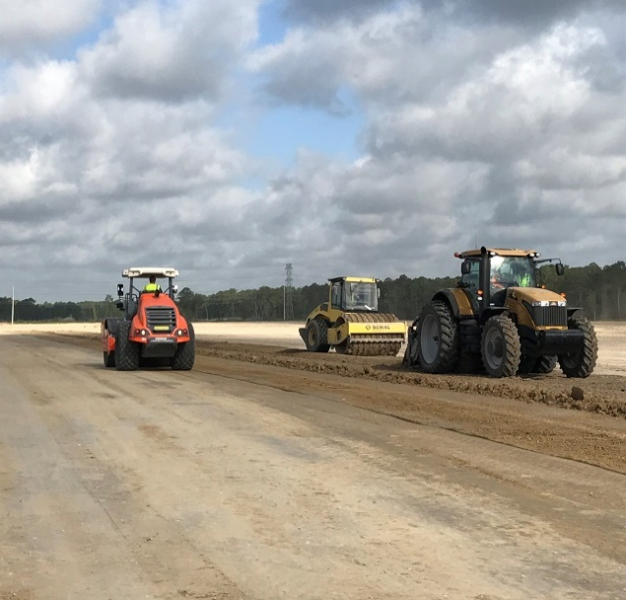
Leading the way to a greener Earth

SoilChem, LLC
117 Snow Drive
Newcastle, OK 73065
405-549-1323

Leading the way to a greener Earth
SoilChem, LLC
117 Snow Drive
Newcastle, OK 73065
405-000-0000
www.soilchemllc.com

